# Paper title-Guidelines

Surnames, Namea; Surnames, Nameb (This field should be filled in when the communication is accepted)

aAffiliation, University and e-mail, b Affiliation, University and e-mail.

Abstract

Abstract in English less than 200 words.

Please use the CIAB 11 template style.

**Submission instructions**: In the first submission of the paper authors must only send a file in PDF (which will include in the text images and plans) generated from this template, strictly observing all these recommendations. To guarantee the anonymous review process, omit all names in the PDF that may compromise the anonymity of the communication, such as names of authors, institutions (which will be left blank at the beginning of the document in the initial submission of the paper), laboratories, programmes, places, etc.

Important: the personal information related to the metadata of the submission MUST be filled in.

Once the paper has been accepted, the authors will send the final text in Word format including personal information and a short Curriculum Vitae in the format defined by the template. The author will also attach a supplementary file in JPG format. (300-400 ppp quality and A4 size) and the plans in PDF (300ppp quality and A4 size)

**Keywords:** Include up to 5 keywords separated by a semicolon.

## General rules

Please use this document to submit your paper to the 11th International Congress on White Architecture (*11º Congreso Internacional de Arquitectura Blanca*, CIAB 11). Authors should use this Word document and the information contained within it as a template for the formatting of their papers, making use of the Word styles included in this document.

Papers will be reviewed by the CIAB 11 Scientific Committee considering the originality of the contribution, the innovation, the structure, the writing style, and the content. The work must be an original contribution to the field of knowledge relative to architectural graphic expression and to architecture, and it must not be published nor have been sent to be published elsewhere. An anti-plagiarism software will be run prior to publication to avoid this situation; any paper that does not strictly observe this recommendation will be automatically rejected for publication.

* 1. **Sections**

The titles will have a maximum of three levels numbered with the decimal system. The main titles (title 1) should be written in Times New Roman, B (bold), 11. The second level (titles 2) will be written in 10-point Times New Roman, B (bold). The third level of titles (titles 3)) will be written in 10-point Times New Roman I (italics).

All titles will have a subsequent spacing of 6 points. After each title, do not leave a blank line, only leave a blank line before starting a new section.

The body text as indicated in this template must be written in 10-point Times New Roman

The captions and tables will be written in 8-point Times New Roman I (italics).

Papers must be concise and follow the structure of a scientific paper providing: (1) an abstract, (2) introduction, (3) discussion, (4) conclusions and (5) bibliographic references. The text should be clearly structured according to academic writing conventions.

* + 1. *Abstract*
    2. *Introduction.* The objectives of the work are to be stated and placed within the context of relevant research.
    3. *Discussion.* The outcome of the work should be clearly described and narrated. The author's work should be placed in the context of architectural graphic expression and indicate its contribution to previously cited work and to the topic addressed.
    4. *Conclusions.* The author should describe the main findings of the research and the original contributions to the topic addressed in the paper.
    5. *Bibliography*
  1. **Illustrations (images and tables)**

Illustrations may include line drawings, diagrams, photographs and digital imagery. All of them are to be considered figures regarding formatting.

Resolution should be at least 300-450 dpi. Figures will be placed after they are mentioned in the text. Do not leave any empty lines above the figure or below the figure caption. All figures should be referenced within the body text abbreviated (Fig. 1). Embed a caption below the figure. The editors will make final decisions regarding the location of the figure. In any case, no more than 10 illustrations will be allowed.

Each figure/table must have a brief descriptive caption that indicates the title, author, course and copyright. Use the template style for the caption. Number all diagrams, figures and photos sequentially, Figure 1, Figure 2, etc. (Table 1, Table 2, etc.), with a one-character space between the number and the caption.

Figures, photographs and tables must be centred. Tables must have a border line at the top and bottom and below the header.

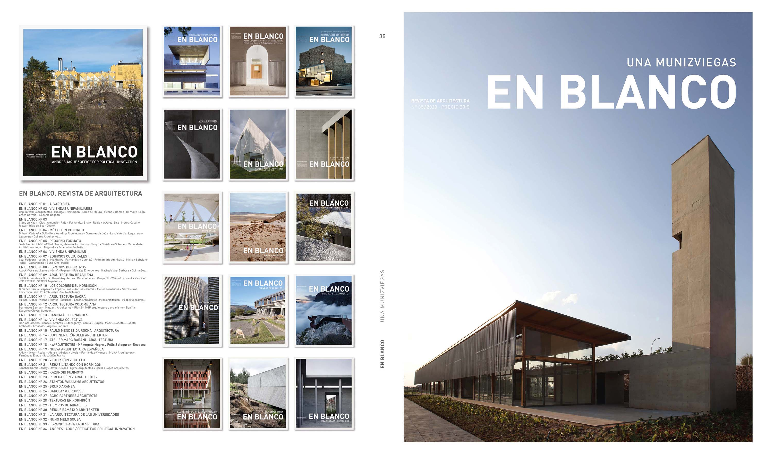

*Figure. 1 Title. Author. Year. Source. Copyright*

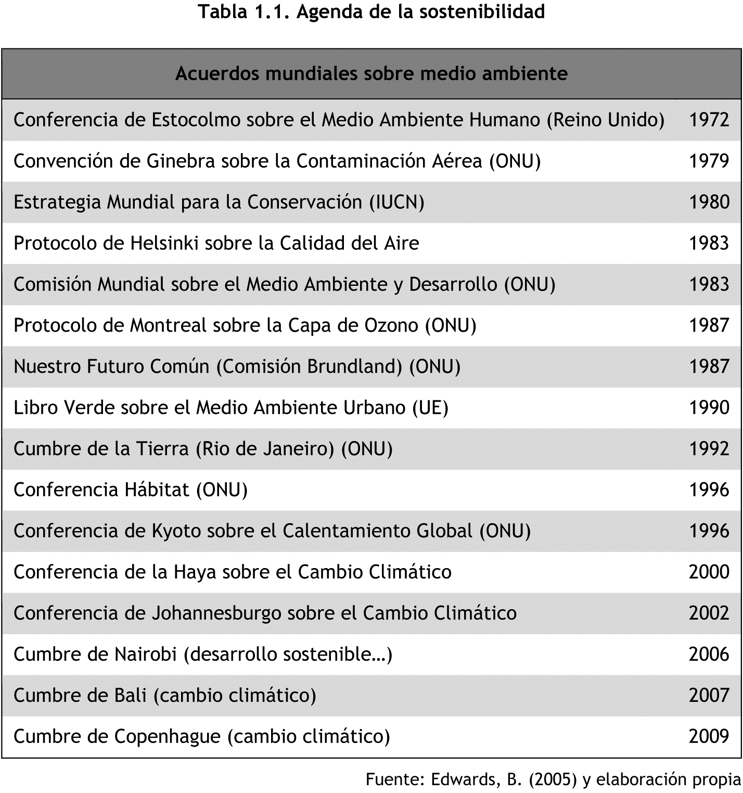

*Table 1. Title. Author. Year. Source. Copyright*

## Accepted Languages and Translations

As it is planned to publish the proceedings with the texts in Spanish and English, authors can submit the paper in English (without the need for a Spanish translation) or in Spanish, in which case an English translation would be necessary once the paper has been accepted. Translations that do not meet the writing and syntax standards of a research paper or that do not comply with the established deadline will be rejected.

## Formatting

Papers should be organized with a clear content-oriented structure. Every paper must have a title and several headings. References follow at the end of the paper using [**The Chicago Manual of Style**](http://www.chicagomanualofstyle.org/tools_citationguide.html)references citation system. Graphics and tables will be embedded into the text. No empty lines should be inserted after a paragraph.

Body text should be set using the template style, which provides 6 pt. spacing after paragraphs. Emphasis within the text, such as words or key phrases and words in foreign languages, should be italicized. Numbered lists may be allowed; Arabic numbering should then be used. Use only one-line feed after a paragraph. Do not insert any empty lines between paragraphs. Headings should be numbered, except for the designation of the Abstract and Keywords using the templates styles of this document.

## Content, and Wording Extension

The communications of the 11th International Congress of White Architecture (*11º Congreso Internacional de Arquitectura Blanca*, CIAB 11) not only have an autobiographical character of a built project, but also a historical, critical, theoretical or technological nature, showing the latest developments developed by companies in the field of concrete.

Therefore, professionals interested in a **project or research** related to exposed concrete are invited to submit a defined communication within the following fields.

**WORK. Own experiences in architectural and engineering production in which white concrete, exposed or coloured, has played a special role.** Length: between 750 and 1000 words, not counting the abstract, captionsand references**.** The paper will follow the article structure of the Project: It will narrate the objectives/requirements of the project, the influences worked, the concept of architecture, the development and results of the construction, and the technical characteristics of the concrete used.

A maximum of 10 images may be included as part of the paper, as well and the necessary plans of the project: elevations, floors, sections, and representative structural sections.

**RESEARCH. Historical or critical studies related to buildings in concrete.** Length: between 2500-3000 words, not counting the abstract, captions and references. Maximum 10 images as part of the paper the text. The text will follow the structure of the scientific article.

**Important:** In the first submission of the paper authors will only send a file in PDF (that will include images and plans) format generated from this template, thoroughly observing all these recommendations. To guarantee the anonymous review process, omit all names in the PDF that may compromise the anonymity of the communication, such as names of authors, institutions (which will be left blank at the beginning of the document in the initial submission of the paper), laboratories, programmes, places, etc.

Once the paper has been accepted: the technical data of the work will be added (Architects, collaborators, promoter, builder, year of project and completion, location, budget, etc) or of the authors of the scientific article (including their affiliation) and a short Curriculum Vitae in the format defined by the template. Additionally, the author will also attach a supplementary file in JPG format. (300-400 ppp quality and A4 size) and the plans in PDF format (300ppp quality and A4 size). Images and plans must be free of copyright for publication, or in their case the rights have been paid or negotiated by the author with the corresponding entity.

## References and citation style

The papers will follow the instructions of [**The Chicago Manual of Style**](http://www.chicagomanualofstyle.org/tools_citationguide.html)**.**

References will be ordered alphabetically according to the names of the authors. If more than one author is cited, the publications will be ordered by date.

In the 'Own Experiences' section, at least four bibliographical references that provide scientific background to what is considered research of the architectural project should be included.

All notes will be included at the end of page following the instructions of [**The Chicago Manual of Style**](http://www.chicagomanualofstyle.org/tools_citationguide.html)**.**

Any quotation or bibliographic reference indicated in a footnote must be included in the bibliography at the end of the article.

## Submitting Your Manuscript

Please refer to the following page for instructions on the submitting papers.

<http://ocs.editorial.upv.es/index.php/CIAB/CIAB11/schedConf/cfp>

## Consent to Publish form

If your paper is chosen for publication you will be sent a “Consent to Publish form” that we will provide from the Congress’ organization.

## Author bio statement (only to be filled in once the paper is accepted)

Brief biographical statement of the author/authors, with indication of degrees, professional career and teaching category, affiliation, research group, research line(s), etc. E-mail will be included at the end.

## Important Dates

**May 20, 2024:** Call for papers

**October 20, 2024:** Deadline for the submission of full paper

**November 20, 2024:** Notification of acceptance of abstracts (maximun deadline)

**December 20, 2024:** Deadline for the submission of full paper, including modifications and English version.

**February 10, 2024:** Registration deadline

**5th-7th March 2025:** CIAB 11

## Registration

Registration to CIAB 11 is necessary, of at least one of the (co) authors, for the presentation of papers and / or attendance to the different sessions.

Conference Registration. (Login and submission process. Still not available).

For authors and visitors: fee is €90 and includes:

* Attendance certificate
* Participation to all conference sessions
* Attendance at lectures given by diferent international architecture studios.
* Conference proceedings

For students: fee is €30 and includes:

* Attendance certificate
* Participation to all conference sessions.
* Attendance at lectures given by diferent international architecture studios.

All papers and talks given at the congress will be published under the name of CIAB 11, which will be published for the opening day of the congress. Digitally published conferences will be available to anyone interested on the conference website, which will be broadcast live online.